

NATIONAL UNIVERSITY OF TECHNOLOGY ISLAMABAD
DEPARTMENT OF COMPUTER SCIENCE
DIGITAL LOGIC DESIGN LAB

Name | Bisma Fatima
Roll No | 36
Batch | 24
Section | A
Lab Number | 07
Instructor Name | Sir Haseeb
Date of Submission | April 16, 2025
Topic Covered | Implementation and Verification of Decoders

EXPERIMENT 7
Implementation and Verification of Decoders
Objective
- To experimentally verify the operation of a decoder
- To higher order decoder using lower order decoders
- construct
Tools/Equipment Requirement
- Logic Gate ICs as required
- Dual 2 x 4 Decoder IC 74139
- Digital Electronics trainer.
Activity Time Boxing
Task No. | Activity Name | Activity Time
1 | Briefing of Decoder and IC of decoders | 15 ~ 20 mins
2 | Designing using logic gates | 10 ~ 15mins
3 | Design 3 x 8 decoder using 2 x 4 decoder IC | 10 ~ 15mins
4 | Performance of tasks and recording of observations in Truth Table. | 100~110min
5 | Output Verification and Viva | 15 ~ 20 mins
Total Time: 180

Theoretical Explanation
Decoder
The basic function of a decoder is to detect the presence of a specified combination of code on its inputs and to indicate the presence of that code by a specified output level. In its general form, a decoder has ‘n’ input lines to handle ‘n’ bits and form 2^{n} output lines to indicate the presence of one or more n bit combinations.
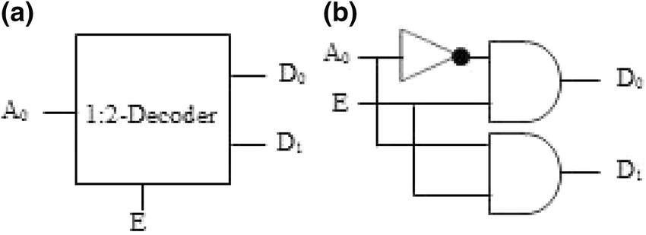
Procedure
2 to 4 Line Decoder
- From the truth table derive the logic equation.
A | B | D0 | D1 | D2 | D3
0 | 0 | 1 | 0 | 0 | 0
0 | 1 | 0 | 1 | 0 | 0
1 | 0 | 0 | 0 | 1 | 0
1 | 1 | 0 | 0 | 0 | 1
TRUTH TABLE : 01
Explanation:
A 2-to-4 decoder takes 2 binary inputs and activates one of 4 outputs based on the input combination. Only one output is active at a time, while the others remain inactive. The output corresponds directly to the binary value of the inputs.
- From the logic equations from step 1, draw the logic diagram for the decoder.
By using the truth table 01;
FOLLOWING ARE THE EQUATION FOR D0,D1,D2,D2:
- D0: A’.B’
- D1: A’.B
- D2: A.B’
- D3: A.B
LOGIC DIAGRAM
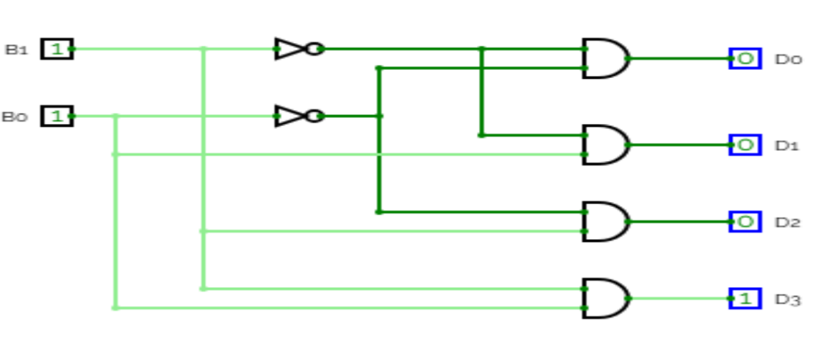

- Now looking at the circuit diagram verify the 2 to 4-line decoder operation on digital electronics trainer.
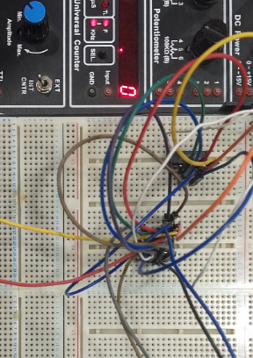
Explanation:
On breadboard we have taken two input A and B . By decorder we have four outputs but at a time one output is activated and other are deactivate. For this purpose we have used ONE AND IC CHIP ( four gate) and ONE NOT IC CHIP (two gates) and make the possible connection using TRUTH TABLE 01 and CIRCUIT DIAGRAM .

3 to 8 Line Decoder
A 3-to-8 line decoder has 3 inputs and 8 outputs
- Complete the truth table for a 3-to-8 line decoder.
A | B | C | D0 | D1 | D2 | D3 | D4 | D5 | D6 | D7
0 | 0 | 0 | 1 | 0 | 0 | 0 | 0 | 0 | 0 | 0
0 | 0 | 1 | 0 | 1 | 0 | 0 | 0 | 0 | 0 | 0
0 | 1 | 0 | 0 | 0 | 1 | 0 | 0 | 0 | 0 | 0
0 | 1 | 1 | 0 | 0 | 0 | 1 | 0 | 0 | 0 | 0
1 | 0 | 0 | 0 | 0 | 0 | 0 | 1 | 0 | 0 | 0
1 | 0 | 1 | 0 | 0 | 0 | 0 | 0 | 1 | 0 | 0
1 | 1 | 0 | 0 | 0 | 0 | 0 | 0 | 0 | 1 | 0
1 | 1 | 1 | 0 | 0 | 0 | 0 | 0 | 0 | 0 | 1
TRUTH TABLE 02
Explanation:
A 3-to-8 decoder takes 3 binary inputs and activates one of 8 outputs based on the input combination. Only one output is active at a time, while the others remain inactive. The output corresponds directly to the binary value of the inputs.

- Design a circuit diagram for implementing 3 x 8 decoder using two 2 x 4 decoders.
By using the truth table 02;
FOLLOWING ARE THE EQUATION FOR D0,D1,D2,D3,D4,D5,D6,D7:
- D0: A’.B’.C’
- D1: A’.B’.C
- D2: A’.B.C’
- D3: A’.B.C
- D4: A.B’.C’
- D5: A.B’.C
- D6: A.B.C’
- D7: A.B.C

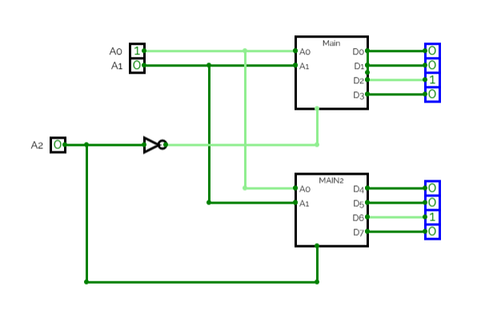
- Implement the circuit on trainer.
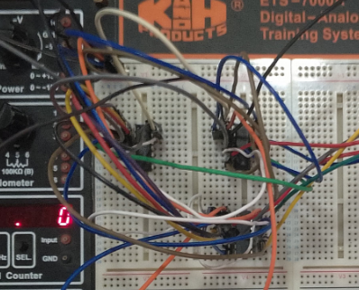
Explanation :
On breadboard we have taken THREE input A, B AND C. By decorder we have EIGHT outputs but at a time one output is activated and other are deactivate. For this purpose we have used TWO 2-to-4 line decorders and connect them with three inputs.

- Apply all possible combinations of inputs. Observe and record the outputs.
Verification of Truth Table
The circuit's behavior was validated by testing all possible combinations of inputs A, B, and C.
- When A = 0, B = 0, and C = 0, the output D0 was 1, while all other outputs were 0, matching the expected result.
- When A = 1, B = 0, and C = 1, the output D5 was 1, with all other outputs being 0, as specified in the truth table.

Functional Validation
The system's functionality was confirmed by applying all possible input combinations to A, B, and C. The output results aligned with the truth table predictions:
- Input ABC = 000 yielded output D0 = 1, with all other outputs at 0.
- Input ABC = 101 produced output D5 = 1, while all other outputs remained at 0.

Testing and Validation
All possible input combinations for A, B, and C were tested, and the results were compared to the truth table. The circuit behaved as expected:
- For input ABC = 000, D0 = 1 and all other Di = 0.
- For input ABC = 101, D5 = 1 and all other Di = 0.

Post Lab Task
Design 4-to-16 line decoder draw its logic diagram and truth table and verify your results by testing your circuit on circuitVerse.
TRUTH TABLE
A | B | C | D | D15 | D14 | D13 | D12 | D11 | D10 | D9 | D8 | D7 | D6 | D5 | D4 | D3 | D2 | D1 | D0
0 | 0 | 0 | 0 | 0 | 0 | 0 | 0 | 0 | 0 | 0 | 0 | 0 | 0 | 0 | 0 | 0 | 0 | 0 | 1
0 | 0 | 0 | 1 | 0 | 0 | 0 | 0 | 0 | 0 | 0 | 0 | 0 | 0 | 0 | 0 | 0 | 0 | 1 | 0
0 | 0 | 1 | 0 | 0 | 0 | 0 | 0 | 0 | 0 | 0 | 0 | 0 | 0 | 0 | 0 | 0 | 1 | 0 | 0
0 | 0 | 1 | 1 | 0 | 0 | 0 | 0 | 0 | 0 | 0 | 0 | 0 | 0 | 0 | 0 | 1 | 0 | 0 | 0
0 | 1 | 0 | 0 | 0 | 0 | 0 | 0 | 0 | 0 | 0 | 0 | 0 | 0 | 0 | 1 | 0 | 0 | 0 | 0
0 | 1 | 0 | 1 | 0 | 0 | 0 | 0 | 0 | 0 | 0 | 0 | 0 | 0 | 1 | 0 | 0 | 0 | 0 | 0
0 | 1 | 1 | 0 | 0 | 0 | 0 | 0 | 0 | 0 | 0 | 0 | 0 | 1 | 0 | 0 | 0 | 0 | 0 | 0
0 | 1 | 1 | 1 | 0 | 0 | 0 | 0 | 0 | 0 | 0 | 0 | 1 | 0 | 0 | 0 | 0 | 0 | 0 | 0
1 | 0 | 0 | 0 | 0 | 0 | 0 | 0 | 0 | 0 | 0 | 1 | 0 | 0 | 0 | 0 | 0 | 0 | 0 | 0
1 | 0 | 0 | 1 | 0 | 0 | 0 | 0 | 0 | 0 | 1 | 0 | 0 | 0 | 0 | 0 | 0 | 0 | 0 | 0
1 | 0 | 1 | 0 | 0 | 0 | 0 | 0 | 0 | 1 | 0 | 0 | 0 | 0 | 0 | 0 | 0 | 0 | 0 | 0
1 | 0 | 1 | 1 | 0 | 0 | 0 | 0 | 1 | 0 | 0 | 0 | 0 | 0 | 0 | 0 | 0 | 0 | 0 | 0
1 | 1 | 0 | 0 | 0 | 0 | 0 | 1 | 0 | 0 | 0 | 0 | 0 | 0 | 0 | 0 | 0 | 0 | 0 | 0
1 | 1 | 0 | 1 | 0 | 0 | 0 | 1 | 0 | 0 | 0 | 0 | 0 | 0 | 0 | 0 | 0 | 0 | 0 | 0
1 | 1 | 1 | 0 | 0 | 1 | 0 | 0 | 0 | 0 | 0 | 0 | 0 | 0 | 0 | 0 | 0 | 0 | 0 | 0
1 | 1 | 1 | 1 | 1 | 0 | 0 | 0 | 0 | 0 | 0 | 0 | 0 | 0 | 0 | 0 | 0 | 0 | 0 | 0

Logic Diagram:
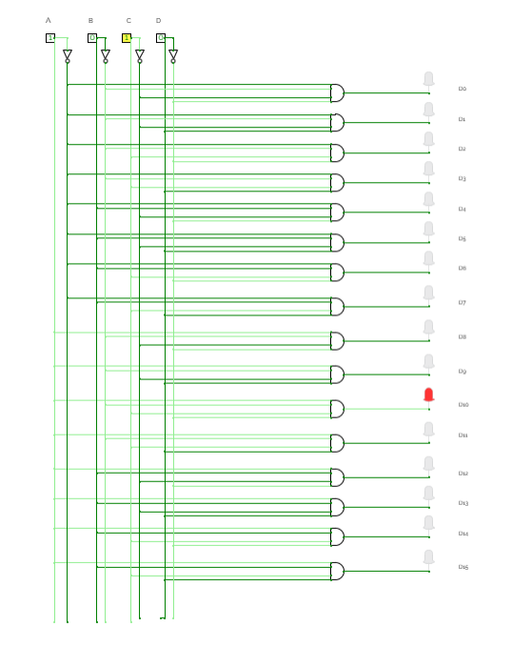
EXPLANATION
To set up and test the 74LS154 4-to-16 decoder, start by positioning the IC on the trainer board and connecting the power supply to the Vcc (pin 24) and GND (pin 12) terminals. Next, link the input pins A (pin 23), B (pin 22), C (pin 21), and D (pin 20) to toggle switches to provide 4-bit binary input combinations. Configure the enable pins G1 (pin 18) and G2 (pin 19) to LOW (0V) to activate the decoder, ensuring both pins are set to LOW for proper operation.
Connect each output pin (Y0 to Y15) to individual LEDs through resistors to observe the active low output, where the selected output goes LOW and all others remain HIGH. Then, apply all 16 possible input combinations (0000 to 1111) using the toggle switches and observe which output line goes LOW for each input, identifying the active output. Finally, compare the observed output with the expected results outlined in the 4-to-16 decoder's truth table to verify the IC's functionality and ensure it operates according to specifications.

APPLICATIONS:
- Memory location selection in computer systems for efficient data storage and retrieval.
- Enabling specific devices like ROM, RAM, or input/output interfaces in microprocessor-based systems.
- Driving 7-segment displays for numerical information display.
- Data multiplexing to route data to specific lines or destinations.
- Instruction interpretation in CPUs to execute specific tasks.
Learning Outcomes
- Understood the working principles of decoders.
- Successfully designed and verified 2-to-4 and 3-to-8 decoders.
- Gained hands-on experience with combinational circuits and logic ICs.

